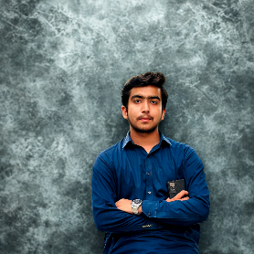
BIO DATA

NAME : Abdul Mateen
FATHERS NAME : Muhammad Safdar Latief
DATE OF BIRTH : 03-07-2007
ADDRESS : House No
GENDER : Male
NATIONALLITY : Pakistani
LANGUAGE : Urdu/English
RELIGION : Islam
MARTIAL STATUS : Single
E-MAIL :xyz@gmail.com
EDUCATIONAL INFORMATION:
EDUCATION | TOTAL MARKS | OBTAINED MARKS
MATRICULATION | 1100 | 1000
INTERMEDIATE | 570 | 500

